**Ideation Phase**

**Brainstorm&Idea Prioritization Template**

|  |  |
| --- | --- |
| Date | 19 September 2022 |
| Team ID | PNT2022TMID10625 |
| Project Name | Online Organic store management |
| Maximum Marks | 4 Marks |

**Brainstorm & Idea Prioritization Template:**

**Step-1: Team Gathering, Collaboration and Select the Problem Statement**

**Problem Statement:**

The problem faced by the company is they do not have any systematic system to record and keep their inventory data. It is difficult for the admin to record the inventory data quickly and safely because they only keep it in the logbook and not properly organized.

**Step-2: Brainstorm, Idea Listing and Grouping**

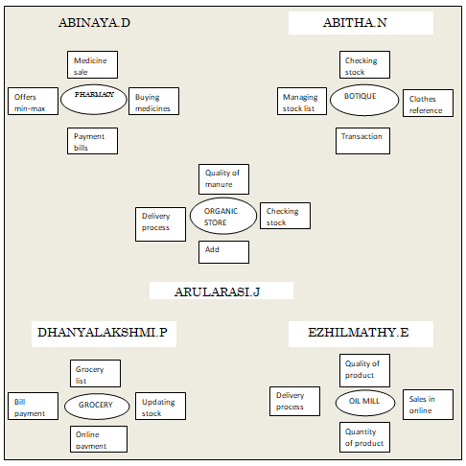

**Step-3: Idea Prioritization**

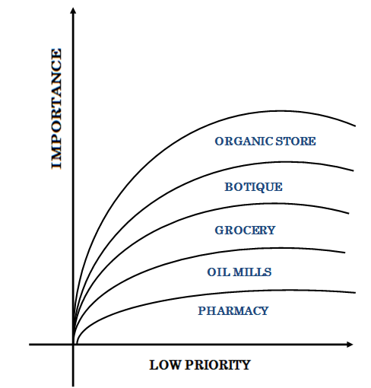

**IDEA PRIORITIZATION:**

Online Organic Store management

1. Good Convenience
2. Efficient for all
3. Customers increment